The Simple Mail Transfer Protocol (SMTP) is an application used by mail servers to send, receive, and relay outgoing email between senders and receivers.
Enabling Telnet in Windows feature on and off is useful for capturing packets while sending an email because Telnet allows you to manually communicate with an email server using the Simple Mail Transfer Protocol (SMTP). This can be helpful for debugging and understanding the email sending process at a low level.
- Telnet: Telnet is a network protocol used to provide a command-line interface for communication with remote devices or servers.
- SMTP: SMTP is the protocol used to send emails across the Internet. By using Telnet, you can manually connect to an SMTP server and send commands directly to it.
- Example: Using Telnet, you can type SMTP commands like HELO, MAIL FROM, RCPT TO, and DATA to manually send an email. This helps in understanding how email servers respond to different commands.

OPEN CMD AND TYPE (telnet gmail-smtp-in.l.google.com 25)….IF this command don’t work the type (telnet smtp.gmail.com 587 )
The command telnet smtp.gmail.com 587 is used to manually connect to Gmail's SMTP server using Telnet on port 587. Here's a breakdown of what each part of the command does:
- telnet: This is the command to start the Telnet client, which allows you to communicate with remote servers using the Telnet protocol.
- smtp.gmail.com: This is the address of Gmail's SMTP server, which is used to send emails.
- 587: This is the port number for the SMTP server. Port 587 is commonly used for sending emails securely using the STARTTLS command to upgrade to an encrypted connection.
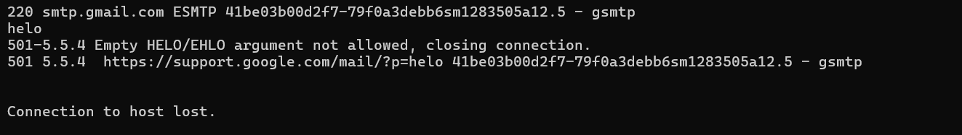
This is the picture of cmd after building connection with google server using smtp……..
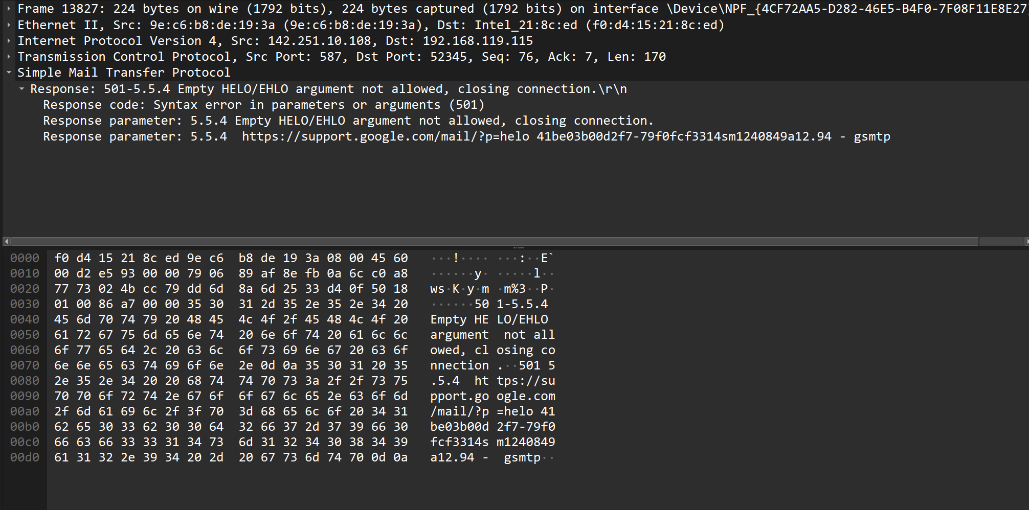
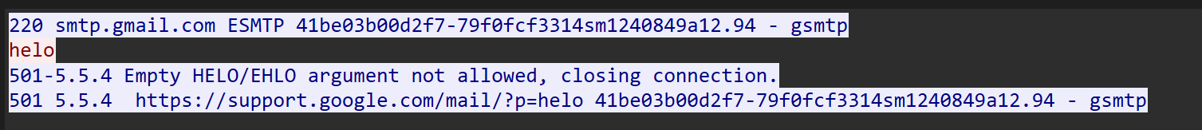
Same packet has been captured in wireshark..

